PROJECT DOCUMENT
COMIC CRAFT-AI COMIC STORY CREATOR USING
GEMINI MODELS

Team ID: SWTID-2026-2016
Team Size: 5
Team Leader: TONI PRIYA
Email: tonipriya3011@gmail.com
Team member: ROSHINI S
Email: roshinis078@gmail.com
Team member: LAVANYA E
Email: lavanyalavanya40984@gmail.com
Team member: LOGEETHA K
Email: logeethak2006@gmail.com
Team member: ROOPA SREE R
Email: roopakaviram1301@gmail.com

ComicCraft - AI Comic Story Creator using Gemini Models

Project Description:
ComicCraft is an AI-powered web application designed to turn user ideas into customized comic stories and illustrations. It uses FastAPI as the application framework and combines Google Gemini models with Stable Diffusion to automate story planning, dialogue creation, and comic-image generation.
Users enter details such as the story idea, main character, setting, tone, and preferred art style. From these inputs, the application creates a panel-by-panel storyline with related illustrations. The completed comic can be previewed in the browser and exported as a PDF containing both images and story text.
The application provides a straightforward HTML interface and uses Hugging Face Diffusers for image generation. Its modular workflow helps maintain consistency across panels while keeping the creation process accessible to beginners, non-artists, and casual users. Both API endpoints and a web interface are provided.
Scenarios:

Scenario 1 : A user enters a story idea such as “A brave fox exploring an enchanted forest.” ComicCraft interprets the prompt and creates a sequence of comic panels containing text and images. The user can also specify the hero's name, location, tone, and visual style. Gemini 1.5 Pro handles the detailed story content while Stable Diffusion produces the corresponding illustrations, resulting in a customized comic sequence.

Scenario 2: A user wants a bright and humorous comic presentation. The user selects “funny” for the tone and “comic book” for the art style. After submission, ComicCraft repeats the generation process with the updated choices, producing a new outline, story, and set of images. This allows the creator to adjust the mood and visual appearance until the result matches the intended idea.

Scenario 3: After reviewing the generated comic in the browser, the user chooses to download it. The application then follows these stages:
- Layout Binding: The layout_builder.py module combines each panel title, illustration, and story text into an organized comic layout.
- PDF Generation: The exporters.py module uses FPDF to place the panels, images, and narrative content across PDF pages and saves the completed document with a timestamp-based filename.
- Export Success: Once the PDF is created, the user is taken to the export success page. This confirms the completed export and allows the user to keep, print, or share the generated comic.

Technical Architecture:
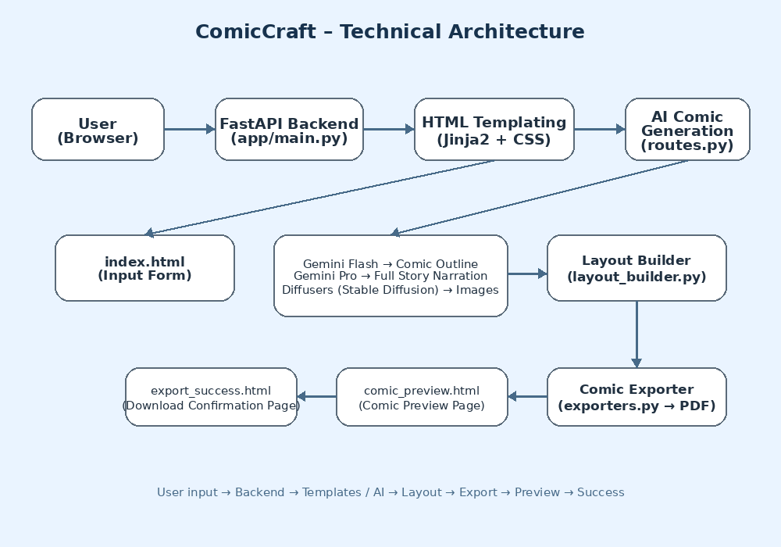
Pre - requisites:
- FastAPI Framework Knowledge: FastAPI Documentation
- Uvicorn ASGI Server: Uvicorn Docs
- Python Programming Proficiency: Python Official Docs
- HTML, CSS, and Jinja2 Template Skills: W3Schools HTML/CSS/Jinja2 Tutorials
- Google Gemini API Familiarity: Google Generative AI Documentation
- Hugging Face Diffusers & Stable Diffusion: Hugging Face Diffusers Documentation
- PyTorch Basics: PyTorch Documentation
- PDF Generation with FPDF: FPDF Documentation
- Version Control with Git:Git Documentation
- Python Package & Environment Setup (pip, virtualenv, or conda): Virtualenv Guide

Project Workflow:
Milestone 1. Model selection and Architecture
Activity 1.1. Research and Select the Appropriate Generative AI Model
Activity 1.2. Define the architecture of the application
Activity 1.3. Set up the development Environment
Milestone 2. Core functionalities Development
Activity 2.1. Develop the core functionalities
Activity 2.2. Implement the FastAPI Backend to Manage Routing and User Input Processing
Milestone 3. route.py Development
Activity 3.1. Writing the Main Application Logic in routes.py
Milestone 4. Frontend Development
Activity 4.1. Designing and Developing User Interface
Activity 4.2. Creating Dynamic Templates with FastAPI’s Jinja2
Milestone 5. Deployment
Activity 5.1. Preparing the Application for Local Deployment
Activity 5.2. Testing and Verifying Local Deployment

Milestone 1. Model selection and Architecture
This milestone focuses on identifying the generative AI models and overall architecture required by ComicCraft. The activities examine model capabilities, application structure, and development setup so the system can create comic outlines, dialogue, scene descriptions, and illustrations effectively.
Activity 1.1: Research and Select the Appropriate Generative AI Model

Understand the Project Requirements
Review the main requirements of ComicCraft and identify the types of output that the application needs to generate:
- Structured comic outlines (panel-by-panel)
- Full comic narration and character dialogues
- Visual comic-style illustrations for each panel
The final system should turn user prompts into creative, understandable, and visually consistent comic content.
Model Evaluation
Examine the documentation and capabilities of the following technologies:
- Google's Gemini Models: Gemini Flash is considered for quick structured responses, while Gemini Pro is used for richer and more detailed creative writing.
- Hugging Face Diffusers: Stable Diffusion is used to create image content from descriptive prompts.
Compare the models using the following practical factors:
- Quality and usefulness of generated narration and character conversations
- Accuracy in following prompts and the level of detail in scene descriptions
- Image generation speed and visual output quality
- Reliability, documentation quality, and available developer support
Different sample prompts were tested to observe how well the selected models handled storytelling and visual generation tasks.

Final Model Selection
Select the models that align with the functional requirements of the ComicCraft application:
- Gemini Flash (models/gemini-1.5-flash):
Selected for fast and structured generation of comic panel outlines based on story prompts.
- Gemini Pro (models/gemini-1.5-pro):
Selected for detailed, creative comic narration and engaging character dialogues.
- Stable Diffusion (runwayml/stable-diffusion-v1-5):
Selected for generating high-quality comic-style illustrations from image prompts.
Using these models together gives ComicCraft a complete generation pipeline in which structured storytelling, detailed narrative content, and comic illustrations are produced as connected stages.
Activity 1.2.Define the architecture of the application

Architecture Overview: The architecture of ComicCraft is structured into three primary components:

Frontend (HTML, CSS, Jinja2)

Backend (FastAPI application)

AI Integration (Google Gemini APIs and Hugging Face Diffusers)

The frontend collects user information and presents the generated comic, the FastAPI backend manages processing and routing, and the AI services generate the required story and image content.

Frontend Responsibilities:

Users access ComicCraft through a simple web interface created with HTML, CSS, and Jinja2 templates.

The main information entered by the user includes:

Story Prompt: Main idea for the comic

Character Name: Hero of the comic

Setting: Location (e.g., forest, school, city)

Story Tone: Mood of the story (e.g., dramatic, funny)

Art Style: Visual style preference (e.g., anime, realistic)

After the form is submitted, the collected information is sent to the FastAPI backend through a POST request.

Templates Used:

index.html: For user input collection

comic_preview.html: To display the generated comic

export_success.html: To show a success message after comic export

Together, these frontend templates provide a continuous path from entering a story idea to viewing and exporting the generated comic.

Backend Responsibilities:
- FastAPI controls the server-side processing and manages the application's routes.
- The main backend tasks include:
  - Receive form data from the frontend or JSON API calls.
  - Call AI models to produce panel outlines, story narration, and illustrations.
  - Organize and build the full comic layout.
  - Export the comic to a downloadable PDF format.
- Routes are defined in routes.py to handle:
  - Form-based and JSON-based comic generation
  - Image testing
  - Comic export confirmation
The backend acts as the connection point between user input, AI processing, comic layout creation, and template rendering.

AI Integration Points:
- Gemini Flash generates a structured five-panel outline from the user's story prompt.
- Gemini Pro then expands the outline into detailed narration and character conversations.
- Stable Diffusion generates comic-style illustrations from the image prompts associated with each panel.
- The backend receives the generated text and images, prepares them for display, and passes them to the frontend for preview and PDF export.
The AI services are called during each generation request, allowing the resulting comic to reflect the information and preferences supplied by the user.
Activity 1.3 Set up the development Environment:
Install Python & Pip: Verify that Python and pip are available on the development machine because pip is required to install and manage the project's libraries.
Create Virtual Environment: Create an isolated environment so ComicCraft dependencies remain separate from packages used by other Python projects.
python -m venv comiccraft-env
comiccraft-env\Scripts\activate # For Windows
Install Required Libraries:
pip install fastapi uvicorn jinja2 python-multipart google-generativeai diffusers transformers fpdf Pillow accelerate
Run Server:
uvicorn app.main:app --reload
Visit http://127.0.0.1:8000 for the app and /docs for API testing.
Set Up Project Structure:
Create the basic folders and files required for the ComicCraft application:
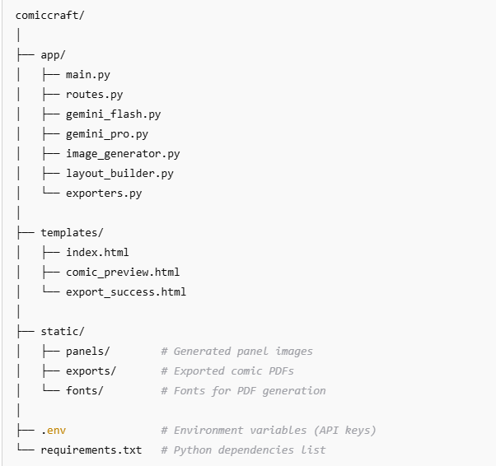
Milestone 2. Core functionalities Development
Activity 2.1 Develop the core functionalities:

Generate Structured Comic Panel Outline
Function: generate_outline()
File: gemini_flash.py
- The generate_outline() function uses Gemini Flash to convert the user's story prompt into a structured five-panel outline.
- Each generated panel contains its number, a title, a scene explanation, and a prompt that can be used for image generation.
- The function provides the application with a list of panel dictionaries that can be processed by the later stages.
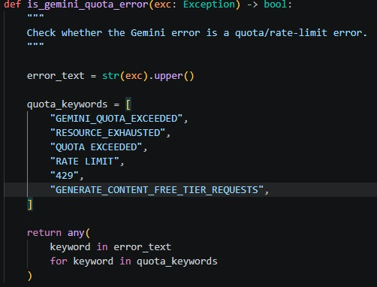
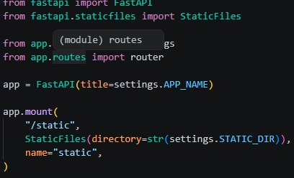
Generate Comic Story Narration and Dialogue
Function: generate_story()
File: gemini_pro.py
- The generate_story() function uses Gemini Pro to expand the panel outline into a complete comic-style narrative.
- For every panel, it creates suitable narration and character dialogue that follow the generated storyline.
- The output is returned as a formatted text block containing the story for the complete set of panels.
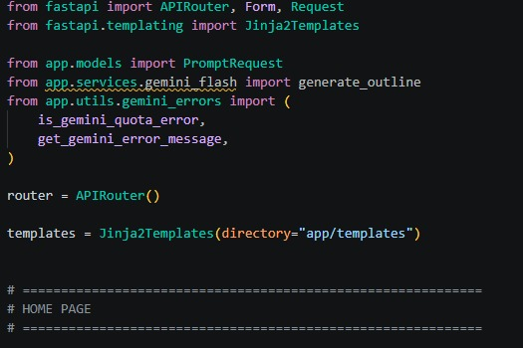

Generate Comic Illustrations from Prompts
Function: generate_image()
File: image_generator.py
- The generate_image() function sends the supplied visual prompt to Stable Diffusion and creates a comic-style illustration.
- Before saving the result, the function prepares the prompt for a suitable filename and stores the generated image inside the static/panels directory.
- The function provides the saved image location so that other parts of the application can use it.
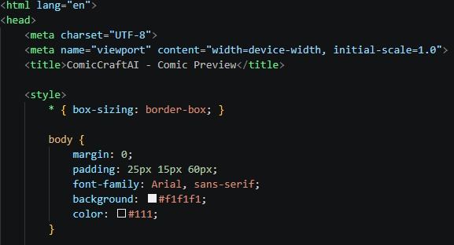
Organize Comic Panels into Layout Structure
Functions: build_comic_layout()
File: layout_builder.py
- This function combines the generated illustrations and story content into an ordered comic layout.
- Each illustration is matched with the story information belonging to the same panel.
- The result is a list of dictionaries containing the panel number, image location, and associated text.

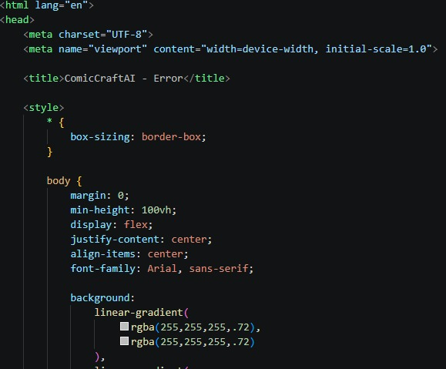

Export Comic Panel and Story into PDF
Function: save_pdf()
File: exporters.py
- The save_pdf() function uses the FPDF library to combine the complete comic content into a multi-page PDF document.
- For readability, each panel's illustration and related narration are positioned clearly within the generated pages.
- After creation, the PDF is placed in the static/exports folder and its file path is returned.
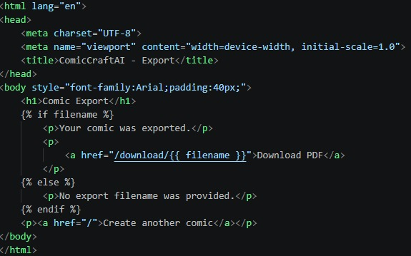

Activity 2.2: Implement the FastAPI Backend to Manage Routing and User Input Processing

Define Routes in FastAPI
Routing operations are handled through routes.py. Each endpoint connects the incoming request with the appropriate backend functions used in the comic-generation workflow.
Process User Input
- HTML Form: produced in index.html
- Users enter the story prompt, character name, setting, tone, and art style through the application form.
- FastAPI reads the submitted form values through Form(...) request parameters.
- For JSON-based generation, the Pydantic PromptRequest schema checks and validates the incoming data.

Integrate Gemini API Calls
Each route handler invokes the appropriate AI and layout functions according to the requested operation:
- /generate →
  - Calls generate_outline() to create the panel structure from the submitted story prompt
  - Calls generate_story() to develop the panel outline into narration and dialogue
  - Calls generate_image() for every panel to create the required illustrations
  - Calls build_comic_layout() to combine the generated panel information into the final structure
  - Calls save_pdf() to assemble the completed comic and create the downloadable PDF
- /generate-comic/json →
  - This endpoint follows the same generation sequence as /generate, but receives the information through a JSON API request.
  - The endpoint returns the generated layout information together with the location of the exported PDF for API clients.
- /test-image →
  - Calls generate_image() directly with a supplied prompt so image generation can be tested independently from the complete comic workflow.
Generated text and images are formatted and supplied to the Jinja2 templates, allowing the preview and export pages to display the results in an organized manner.

Milestone 3. routes.py Development
This milestone concentrates on implementing the main FastAPI routes, processing user submissions, connecting the AI functions, and coordinating communication between the backend and frontend.
The completed route structure provides the basic foundation needed to accept prompts, generate comic content, display the result, and support API-based testing.

Activity 3.1: Writing the Main Application Logic in routes.py

Defining Core routes in routes.py:
The following routes were created to support the main ComicCraft functions:
- / → Opens the homepage (index.html) where users enter their comic information.
- /generate → Receives form data, starts the AI generation workflow, creates the panels, and displays the comic preview.
- /generate-comic/json → Accepts JSON input, runs the comic-generation pipeline, and returns layout information with the generated PDF path.
- /export-success → Displays confirmation after the generated comic has been exported.
- /test-image → Provides a developer-focused endpoint for checking image generation from an individual prompt.
Each endpoint supports a specific interaction method, either through the browser interface or through direct API communication.
Set up Route Handlers for Each Feature
Each route handler extracts the submitted information using FastAPI form fields or request-body data.
- For /generate, user inputs are captured using Form(...) parameters for:
  - Story prompt
  - Character name
  - Setting
  - Story tone
  - Art style
- For /generate-comic/json, inputs are captured from a JSON body using a PromptRequest model with Pydantic.
The submitted form and JSON information are passed through the required backend functions so the AI workflow can generate content according to the user's choices.
FastAPI error handling is used to manage unexpected problems, including API failures and invalid JSON, with HTTPException and try-except handling.
Integrate AI workflows in each Route
The required AI operations are connected inside the appropriate route handlers:
In /generate and /generate-comic/json:
  - generate_outline() creates the structured five-panel story plan.
  - generate_story() produces the narration and dialogue for the planned panels.
  - generate_image() runs for the individual panels to create their illustrations.
  - build_comic_layout() combines the panel elements into an ordered presentation.
  - save_pdf() joins the story and images into the final PDF export.
The generated results are either supplied to comic_preview.html through the template system or returned as JSON for API consumers.
This arrangement supports a complete comic-creation experience for normal users while also giving developers a structured way to test the backend services.
Comic Generation Route:
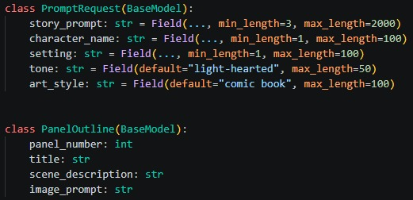

Export Success Route:
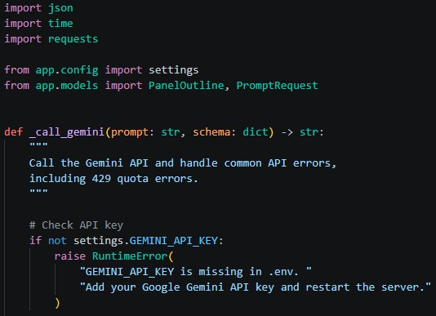

Image generation Route:
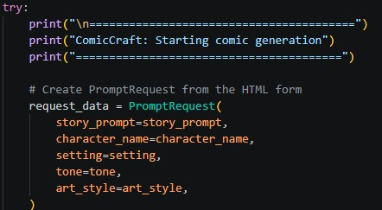

Milestone 4. Frontend Development
This milestone covers the development of the user-facing web pages using HTML, CSS, and Jinja2.
FastAPI renders the templates dynamically, allowing users to submit their information, inspect the generated panels, and complete the export process.
The frontend work creates a clear path between entering a creative idea and receiving the finished comic.

Activity 4.1 Designing and Developing the User Interface

Set Up the Base HTML Structure
The index.html file acts as the main input page. Its form is arranged to collect the following information:
- Story Prompt
- Main Character Name
- Setting
- Story Tone
- Art Style
Each input is clearly labeled and grouped with suitable HTML elements. The page uses a scenic background, readable typography, and an organized form so users can concentrate on developing their story. Navigation is kept simple so the user can move directly from input submission to comic generation.

Design a Responsive Layout Using CSS
CSS styles are included with the HTML pages to create a consistent and readable interface. The content area is centered for easier viewing, buttons include interactive hover behavior, and input/result sections use spacing, rounded corners, and shadows. The overall light layout keeps the interface clear and approachable.

Create Separate Pages for Each Core Functionality
Three Jinja2-powered HTML templates are maintained inside the /templates folder:
- index.html:
Provides the input form for the story prompt, character name, setting, tone, and art style.
The submitted information is sent to the /generate FastAPI route using POST.
- comic_preview.html:
Displays the generated comic sequentially, one panel at a time.
Each panel contains:
  - Title
  - Scene illustration (image)
  - Scene description (in italics)
  - Captions and narration text are displayed with the panel so users can read the story while viewing its illustration. This arrangement makes it easier to follow the comic from beginning to end.
- export_success.html:
Displays confirmation after the comic PDF has been generated and downloaded.
It also provides an option for the user to return and create another comic.
The templates are separated according to their responsibilities, making the interface easier to maintain while keeping movement between comic creation, preview, and export straightforward.
Activity 4.2 Creating Dynamic Templates with FastAPI’s Jinja2
Integrate Jinja2 Templating for Dynamic Content Rendering
- FastAPI's Jinja2Templates component is used to connect backend data with the HTML pages:

from fastapi.templating import Jinja2Templates
templates = Jinja2Templates(directory="templates")

Each FastAPI endpoint uses TemplateResponse to render the appropriate HTML page according to the current user action:
- / route renders index.html
- /generate route renders comic_preview.html
- /export-success route renders export_success.html
This connection allows the displayed comic information, images, and text to update automatically when a new generation request is completed.

Bind Backend Data to HTML Templates
➤ index.html
- Form controls use name="..." attributes that match the corresponding FastAPI Form(...) parameters.
- The form sends the collected values to /generate using POST.
➤ comic_preview.html
- Dynamically shows:
  - Panel number, title
  - Image produced for the panel
  - Scene description (in italics)
  - Captions and narration text
- The template loops through the layout collection with Jinja2 {% for panel in layout %} so each generated panel can be displayed automatically.
➤ export_success.html
- Displays a confirmation message using values supplied through Jinja2.
- Receives the generated PDF path as template context and can provide a control for returning to the homepage.
The frontend and FastAPI backend work together to render AI-generated comic content dynamically and guide the user from prompt entry through preview and export.

Milestone 5. Deployment
This milestone prepares ComicCraft for local deployment through FastAPI. The setup includes configuring the server, installing project dependencies, organizing templates and static files, and running the complete application in a local environment.
The deployment stage verifies that text generation, image creation, layout processing, and PDF export operate together correctly before any future cloud deployment is considered.

Activity 5.1: Preparing the Application for Local Deployment

Set up a virtual environment
Create and activate a virtual environment to keep the project's dependencies isolated. Install the packages listed in requirements.txt, including FastAPI, Uvicorn, Google Generative AI, Hugging Face Diffusers, FPDF, and the other required libraries.

python -m venv env
# For Windows
env\Scripts\activate
# For macOS/Linux
source env/bin/activate

pip install -r requirements.txt

Configure environment variables
- Use environment variables to protect configuration values such as the Gemini API key and Hugging Face API token.
- The values can be entered in the terminal or stored in a .env file and loaded by the application with python-dotenv.
GEMINI_API_KEY=your_gemini_api_key_here
HF_API_KEY=your-huggingface-api-key-here

Frontend-Backend Rendering via Jinja2
User interactions are connected to Jinja2-rendered pages:
- index.html: Collects user inputs
- result.html: shows the produced AI plan
- all_users.html: Lists all user records for admin view

Activity 5.2: Testing and Verifying Local Deployment

Start the FASTAPI Server
Open the project folder containing app/main.py and start the Uvicorn development server with reload enabled:
uvicorn app.main:app --reload

Access the Application Locally
After the server starts, open a browser and enter the local application address:
http://127.0.0.1:8000

This local address opens the ComicCraft homepage, where users can enter their story details and request a personalized AI-generated comic.
FastAPI also provides interactive API documentation that can be opened at:
http://127.0.0.1:8000/docs
The documentation can be used to check and test endpoints such as /generate-comic/json, /generate, /export-success, and /test-image.

Exploring Website’s web pages:

Home page:
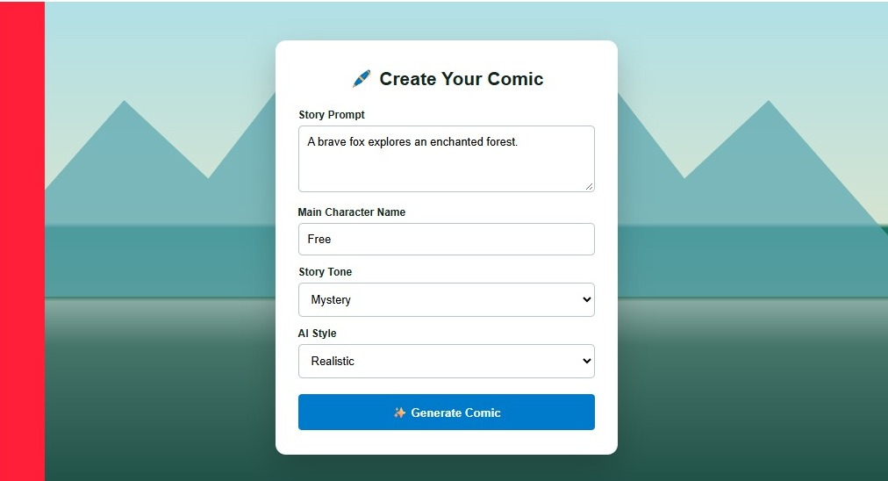
Description:
The ComicCraft homepage provides the starting point for creating an AI-generated comic. A clean layout and scenic background are used to create a creative workspace.
A central form collects the information required for generation. Users can:
- Enter a Story Prompt describing their comic idea,
- Specify a Main Character Name,
- Choose a Setting (school, forest, space, city),
- Select a Story Tone (light-hearted, dramatic, poetic, funny),
- Pick an Art Style (anime, pixel art, comic book, realistic).
After the form is submitted, the AI pipeline creates the comic outline, narrative dialogue, illustrations, and an exportable PDF.
The homepage is intentionally simple and accessible, allowing users to create comics without needing advanced technical knowledge.
Comic Preview- Result page:

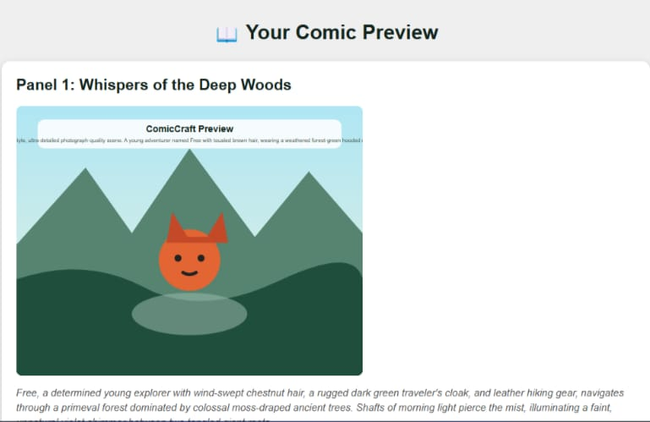

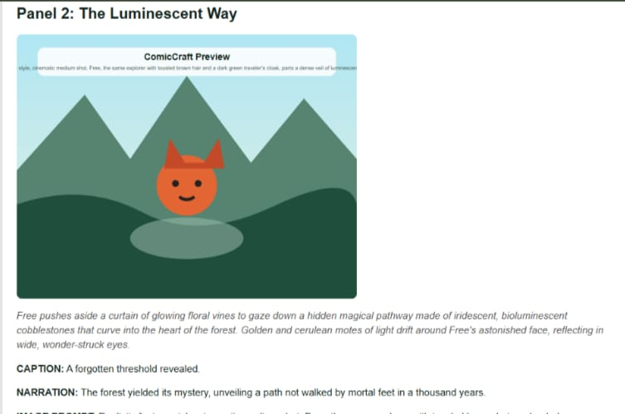

Description:
The Comic Preview Page presents the generated panels in order after the homepage form is submitted. It combines the visual artwork and written story elements so the user can review the complete comic.
Each displayed panel contains the following elements:
- Panel Title: The panel number and a descriptive title identify each section of the comic.
- Comic Image: The illustration generated from the panel's image prompt is shown with the story.
- Scene Description: A short italicized description explains the setting, atmosphere, and context of the panel.
- Caption and Narration:
  - Caption: A short line can describe the surroundings, atmosphere, or background sounds.
  - Narration: The text explains the character's actions, emotions, or spoken content within the scene.
- Image Prompt Reference: The prompt used to guide the illustration is shown as a reference for the generated image.
The preview separates the panels clearly so users can follow the progression of the story. Combining the artwork, scene information, captions, and narration provides a complete view of the generated comic.
The page is primarily intended for reviewing the comic before the user chooses a final action such as PDF export.
Download Button:


Description:
A "Download Your Comic as PDF" button is provided on the Comic Preview Page.
When selected, the application gathers the panel images, titles, scene descriptions, captions, and narration and places them into a formatted PDF saved on the user's device.
The exported file gives users a convenient way to keep, share, print, or read the comic offline.

Comic Export Success Page:

Description:
After the export process begins, the user is directed to the Comic Export Success Page. The page confirms that the AI-generated comic has been created and downloaded successfully. It also provides a "Go produce Another Comic" option for starting a new creation.
The confirmation stage completes the generation workflow by giving the user a clear indication that the final file is ready and providing a simple path back to the comic-creation process.

Conclusion:
ComicCraft demonstrates how generative AI can support digital comic creation by combining Gemini Flash and Gemini Pro for story development with Stable Diffusion for visual generation. The system converts a short user idea into an organized sequence of illustrated comic panels.
The application provides an end-to-end process covering outline creation, narrative and dialogue generation, image production, panel organization, and PDF export through a single web interface. This makes the workflow practical for users who want to create stories without manually producing every comic element.
The present implementation concentrates on generating individual comics and does not include user account management. Because the application is modular, future versions could add user profiles, saved comic collections, and longer multi-page story structures.
Overall, ComicCraft presents a practical example of using AI to support storytelling and visual content creation, helping users move from an initial idea to a completed comic with a structured and automated workflow.

